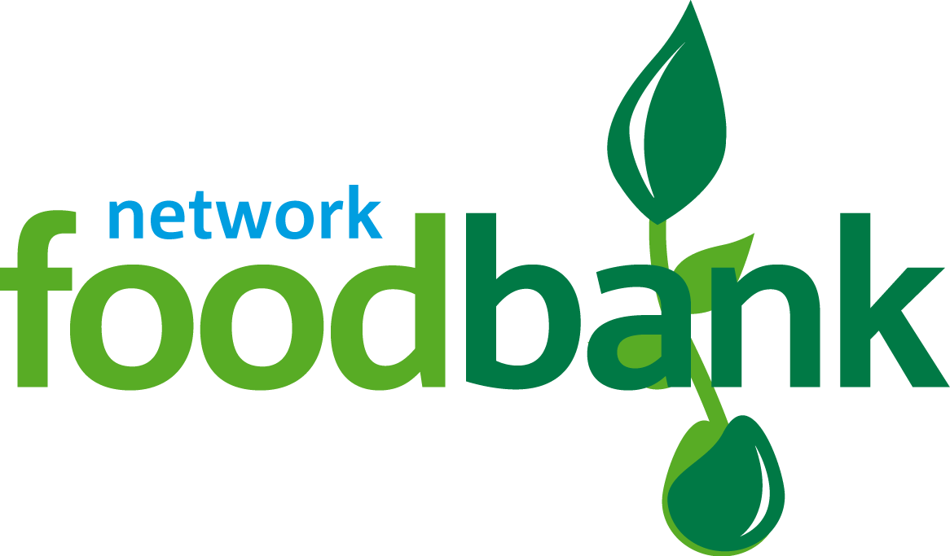

HEALTH & SAFETY POLICY

Doncaster foodbank - Health & Safety Policy

Version | Description | Date
13.3 R1 | Health and Safety Policy | 4th November 2020
Board Approved
For Review: |  | November 2021

Related policies

Version | Description | Date of Update
13.5 R1 | Safeguarding | 4th November 2020
13.9 R1 | Data Protection & Privacy Policy | 4th November 2020
13.6 R1 | Equal Opportunities Policy | 4th November 2020

Doncaster foodbank is committed to ensuring general health and safety in accordance with The Health and Safety at Work Act 1974 and applicable regulations made under it.
Our policy is to ensure the general health and safety of all workers, contractors, volunteers and visitors who attend our premises, or who participate in foodbank activities elsewhere, as far as is reasonable and practicable, as follows:

- To identify health and safety risks, and to control those risks wherever practicable.

- To maintain and, where necessary, replace equipment required for the performance of any particular task.

- To provide safe arrangements for the use, handling, storage or transport of articles and substances.

- To ensure safe use of hazardous substances held.

- To provide adequate information, instruction and training in relation to the performance of employees and volunteers, and to put in place procedures to ensure safe systems of working.

- To provide adequate support and supervision to all employees and volunteers employed on foodbank business.

- To prevent accidents and work-related ill health.

- To review this policy and associated procedures on a regular basis (at least annually) and revise policy and procedures as the need arises.

- To consult employees on health and safety matters.

Signed: 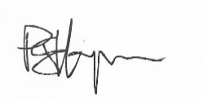 Date: 4 November 2020

Name: Peter Hymans
Position: Chair of Trustees
Doncaster foodbank

Review date: 4 November 2021

